How do I find the Building Security Ordinance mentioned in the letter?
Please view the complete Building Security Ordinance by going to the City website at www.cityofsunprairie.com and clicking on the Code of Ordinances button along the bottom of the page.
The complete Building Security Ordinance can be found under 15.36.035 Building security.
This section of the Ordinance with provide additional details to achieve compliance.

How do I schedule an inspection for compliance?
You may call or email our office to schedule a compliance inspection. buildinginspection@cityofsunprairie.com or 608-825-1184.

DOORS

Must EVERY Exterior door of the building have a viewer including unit side doors, rear doors, etc.?
Only the main door of the dwelling unit must have a viewer.

What is an “approved” door viewer?
It is a peephole or other type of device so a resident can view someone at the main door of their dwelling unit. The main unit door must have a viewer (peephole) if the door has no window.

What height range for the approved door viewer (peephole)?
For a standard unit, the peephole can be mounted between 56” to 64” above the floor. If ADA compliance is necessary, an additional peephole must be mounted at 43” above the floor.

What if the door has a window?
If the door has a window, a viewer is not required.

What about patio doors?
Sliding doors must have both a primary lock, part of the door assembly, and a secondary lock.
Sliding doors on the first-floor level (or accessible by a tree, balcony, fence, etc.), must have a vent lock.
Vent locks must secure the door in the open position between one to five inches open. Acceptable secondary and vent locks include:
- rods or other substantial material cut to the appropriate lengths.
- pins or stops that install in the track.
- adjustable security bars sold for this purpose.

What is a positive locking guarded latch lock?
More commonly known as storeroom locks, these types of locks require a key at all times to gain access to the room or space. Because the outside lever is always inoperable or, in other words, is always locked it means the room will always remain secure once the door is properly closed and latched.
For buildings containing three (3) or more dwelling units, all interior common area doors (such as basements), and any exterior doors entering a common area (such as a hallway to access dwelling units) must close and lock automatically without anyone having to lock the door.

What is an Approved guard plate?
A door security guard plate provides additional protection against forced entry, deterring would-be intruders and helping to keep your property safe.
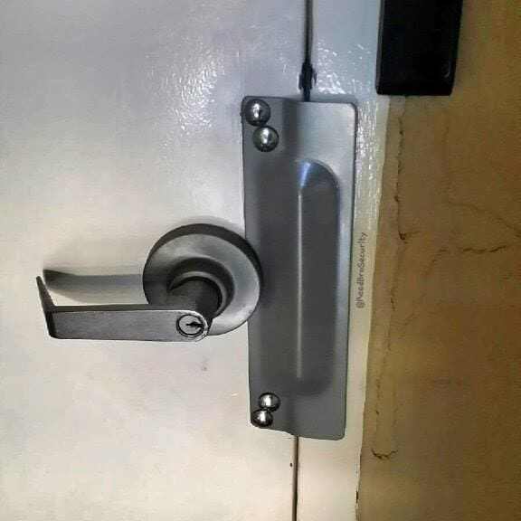

WINDOWS

Sash locks
All basement, first, and second story windows and all other windows accessible by balconies, fire escapes, trees or other existing means shall be provided with sash fasteners (locks) to allow the window to be locked in the closed (shut) position.

Ventilating sash fastener
Also known as vent locks, all single-hung, double-hung, and sliding windows at or below the first floor, and all other windows within reach of porches, balconies, trees, etc. above the first floor must have vent locks. Casement windows are not required to have separate vent locks.
The vent locks must let each window lock to stay between one (1) and five (5) inches open. The locks, when not in use, must let the window open fully from the inside.
There are many styles of vent locks both integrated within windows as well as surface mounted. Below is one example. Provided they meet the above criteria, they are approved for use.

