OpenGov New 1 & 2 Family Construction Application

- Create an account (if you do not already have one) under the Sign-Up tab.

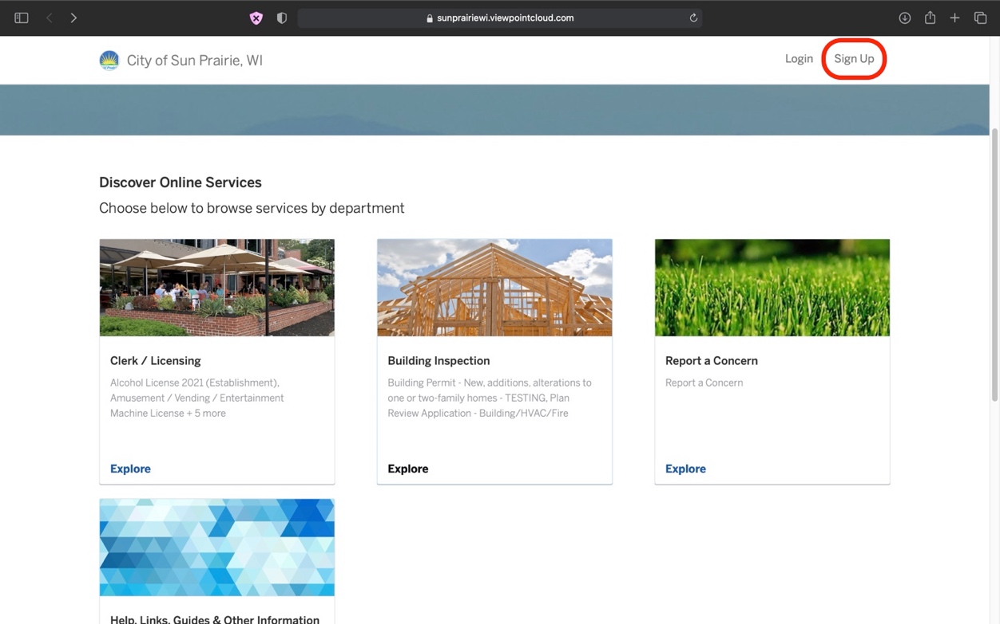

- Once you’ve created an account select the Building Inspection box to view a list of project applications.

- Select Building Permit – New Construction, additions, alterations to one or two-family homes.
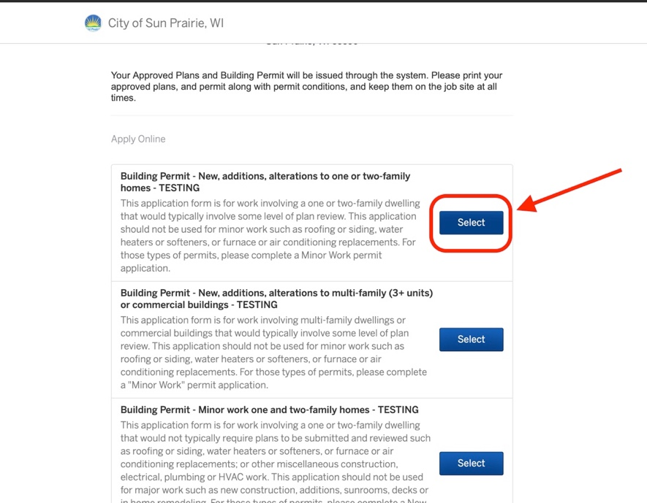

- Click Apply Online
- Sign In
- Confirm the location of the project
- Fill out property owner information

- Select “A new one- or two-family home”

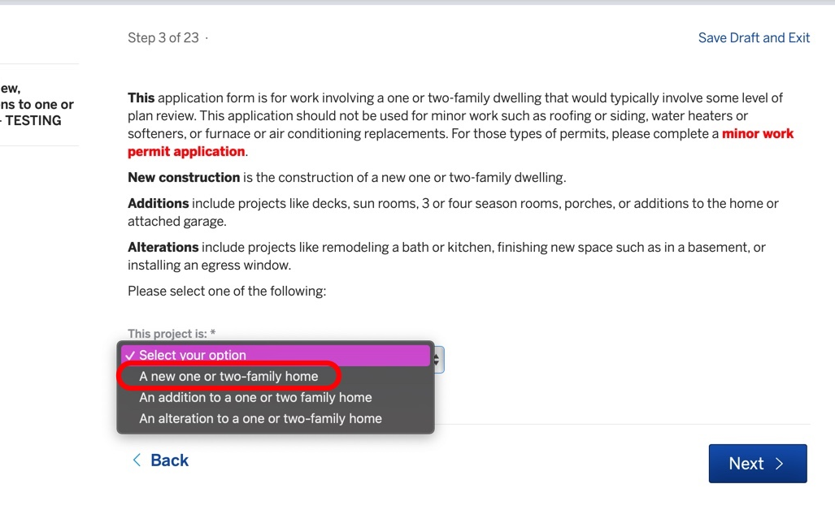

- All documents on this page ARE required.
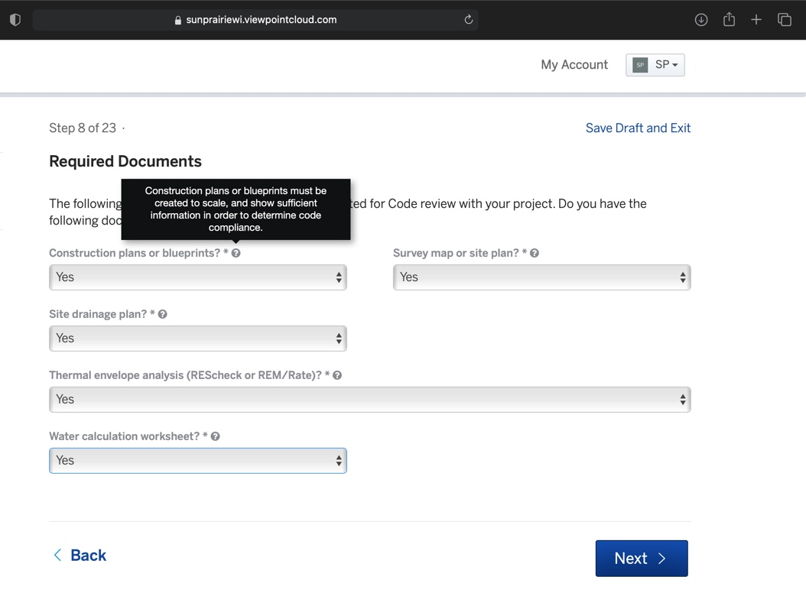

- You will be asked to describe your project.

- Deck or porch plans ARE required to be submitted at the SAME time as new construction plans are submitted.

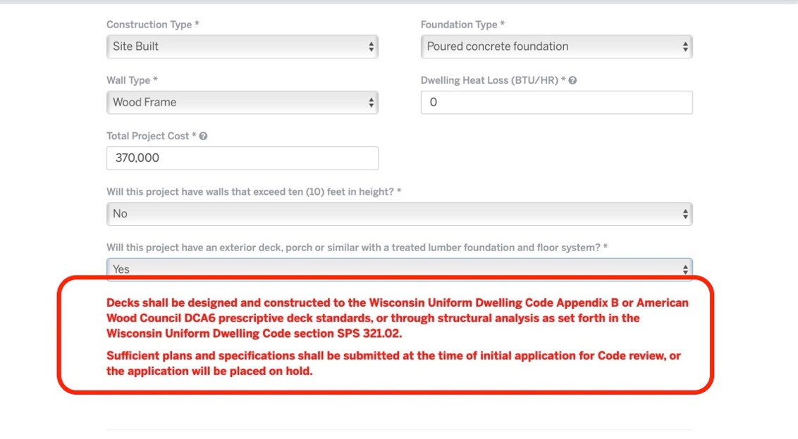

- Continue to follow page steps, select ALL plumbing and HVAC being installed in project.

- Step 15 will require you to enter your contractor information, if your contractors are not found in the system you are able to manually enter their information, please include all info.

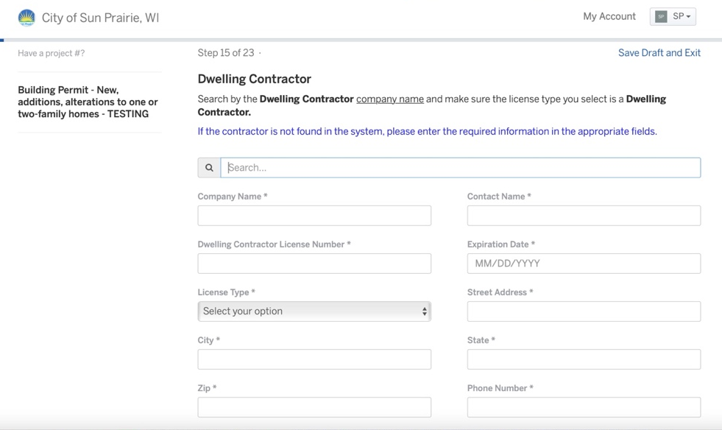

- You will be asked to enter ALL contractors being used in project.

- In step 21 you will have the ability to enter an Early Start Permit, the fee for this will be due IMMEDIATELY upon completion of your application.

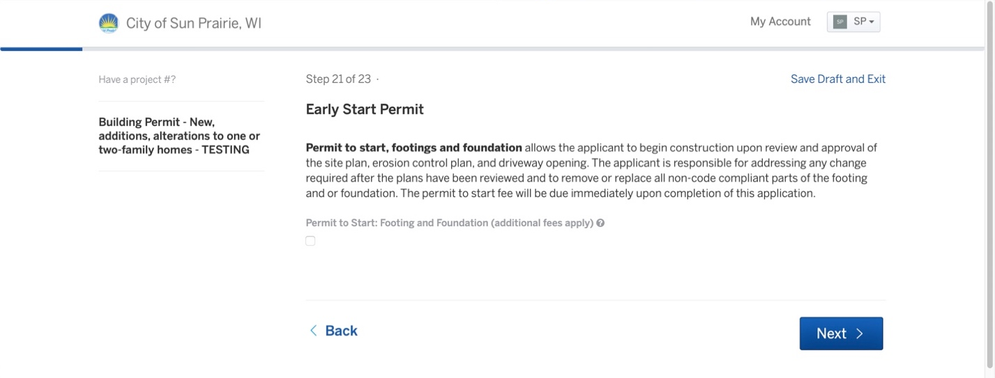

- Next you will be asked to digitally sign your application, simply click the signature box and type your FULL legal name.

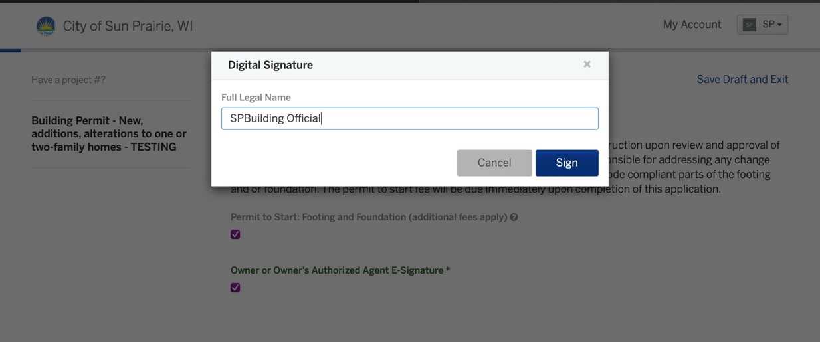

- To upload your required documents click upload and select the document you want to upload for that section.

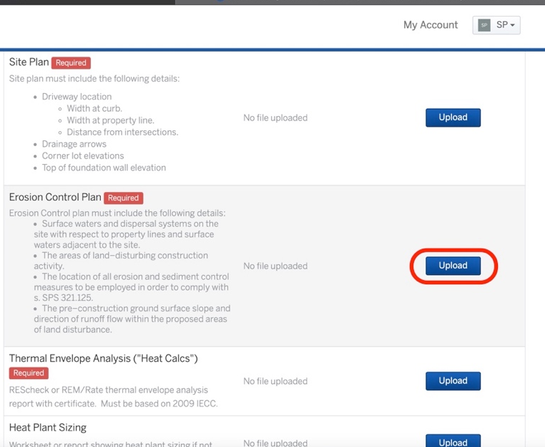

- After all your documents are uploaded you will have a chance to review all information submitted in application, if you are satisfied you may click submit.

- You are now FINISHED with the New 1 & 2 Family Construction Application!

